Inventory Management System

1. **Creating the tables.**

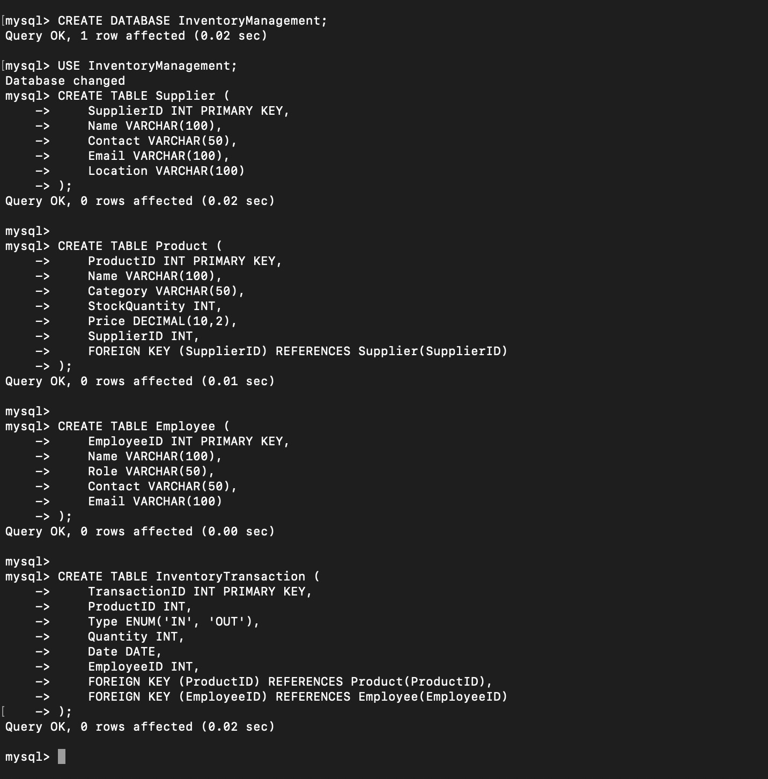

1. **Inserting sample data.**

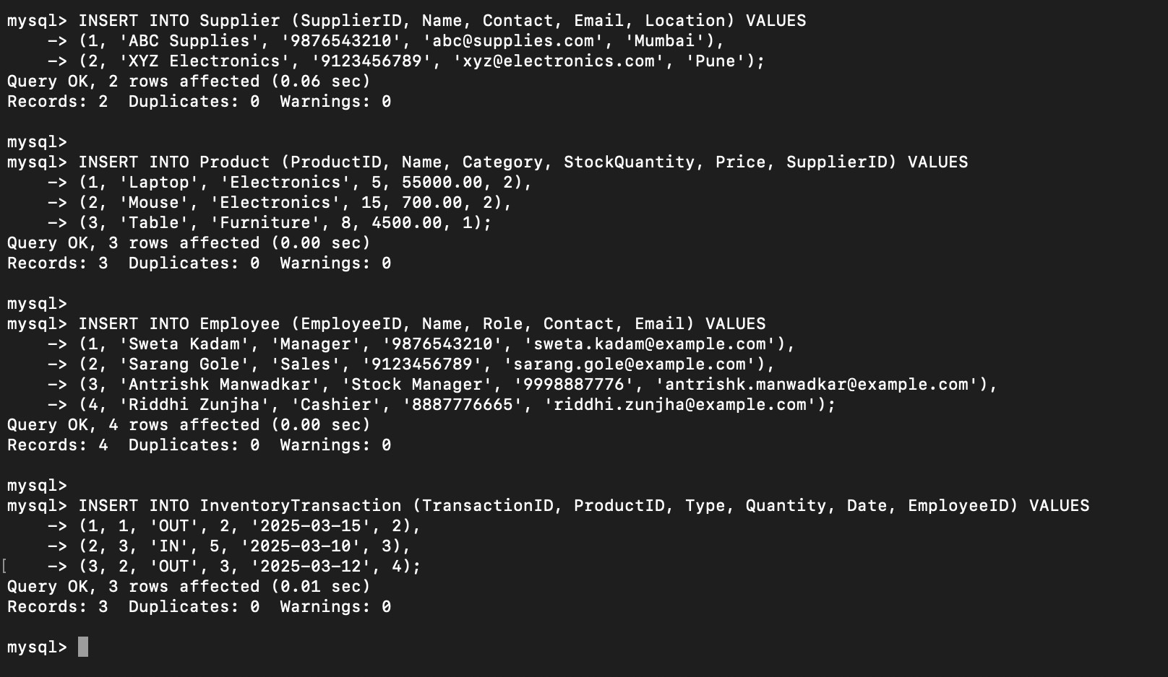

1. **Retrieve all products with less than 10 stock remaining.**

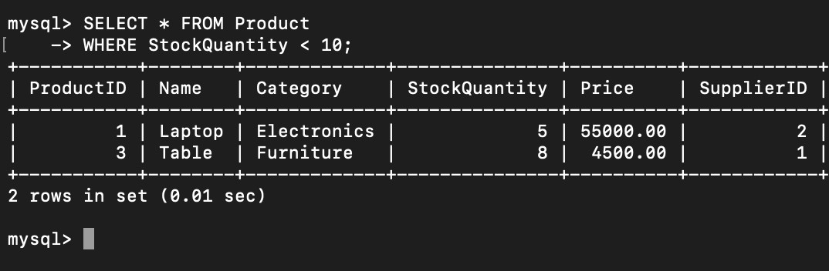

1. **Find suppliers supplying “Electronics” category products.**

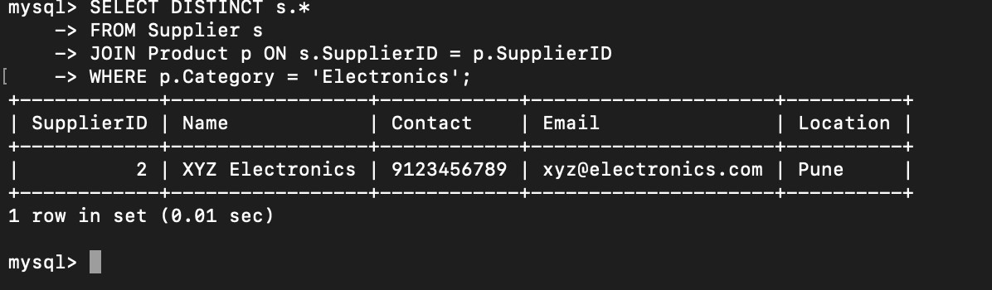

1. **Display the total stock for each product category.**

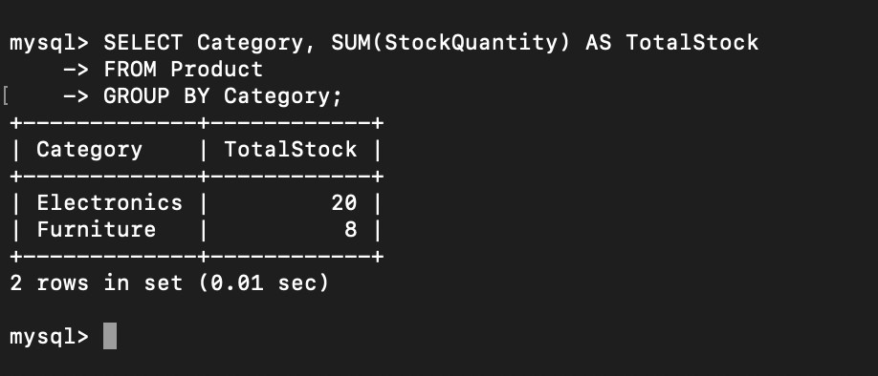

1. **Retrieve inventory transactions for the last 30 days.**

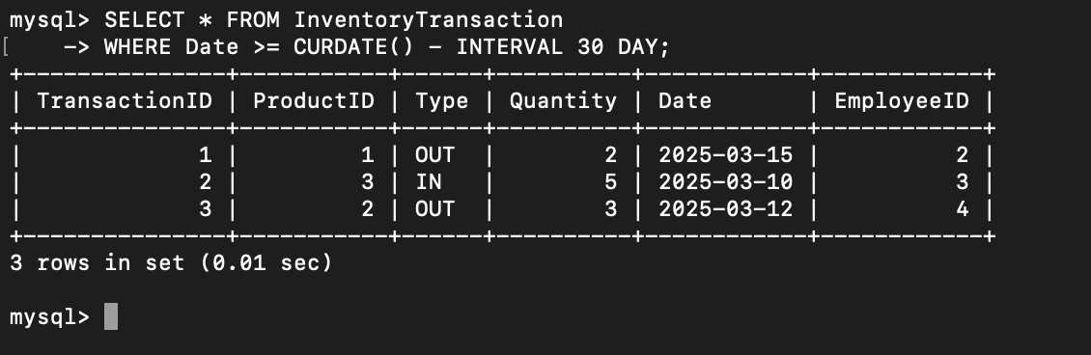

1. **Find employees who have processed more than 50 transactions.**

